**Excel Assignment 3**

1. What do you mean by “Relative Cell Referencing” in MS Excel and “Absolute cell referencing”?

By default, all cell references are **relative references**. When copied across multiple cells, they change based on the relative position of rows and columns. For example, if you copy the formula **=A1+B1** from row 1 to row 2, the formula will become**=A2+B2.**Relative references are especially convenient whenever you need to **repeat** the same calculation across multiple rows or columns

An absolute reference is designated in a formula by the addition of a **dollar sign ($)** before the column and row. If it precedes the column or row (but not both), it's known as a **mixed reference**.

1. How to secure an excel workbook, demonstrate it with an example.

Click Review > Protect Workbook.

Enter a password in the Password box. ...

Select OK, re-enter the password to confirm it, and then select OK again.

1. Explain the pivot tables and their implementations.

A PivotTable is an interactive way to quickly summarize large amounts of data. we can use a PivotTable to analyse numerical data in detail, and answer unanticipated questions about your data. A PivotTable is especially designed for: Querying large amounts of data in many user-friendly ways.

Select the cells you want to create a PivotTable from. ...

Select Insert > PivotTable.

This will create a PivotTable based on an existing table or range. ...

Choose where you want the PivotTable report to be placed. ...

Click OK.

1. Explain lookup in excel with suitable examples.

The lookup and reference functions, when we need to look in a single row or column and find a value from the same position in a second row or column. For example, let's say we know the part number for an auto part, but you don't know the price. You can use the LOOKUP function to return the price in cell H2 when you enter the auto part number in cell H1.

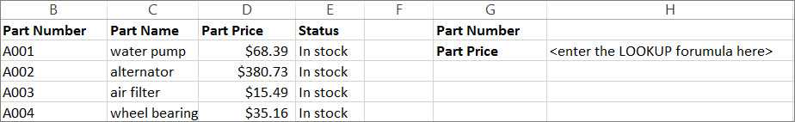

1. What is Data validation, and how to implement it in Excel?

Excel can restrict data entry to certain cells by using data validation, prompt users to enter valid data when a cell is selected, and display an error message when a user enters invalid data.

Select one or more cells to validate.

On the Data tab, in the Data Tools group, click Data Validation.

On the Settings tab, in the Allow box, select List.

In the Source box, type your list values, separated by commas. ...

Make sure that the In-cell dropdown check box is selected.